Modified 6LoWPAN and UDP for IoT Devices

Name: Uday,nahin hossain ID : 17-33297-1
Department:CSE
Institute:American International University Bangladesh
Name: Mim, Kanis Rahela ID:17-34816-2
Department:CS
Institute:American International University Bangladesh

Name:Hasan, Mohd. Mahdi
ID:17-33599-1
Department:CSE
Institute:American International University Bangladesh
Name: Ahmed Naznin
ID: 15-29530-2
Department:CSE
Institute:American International University Bangladesh.

Abstract
In 6LoWPAN, while packet transferring TCP protocol is time consuming. So UDP is vastly used for 6LoWPAN but UDP is not reliable which can cause major problems when IoT is used in a greater range.The RUDP is a reliable connection-oriented protocol, which uses a three-way handshaking to overcome error in connection and a resending mechanism for packet loss. So we proposed a modified version of RUDP which will include an serialID in header. Several sets of experiments was taken in consider to analyze the performance of the RUDP, comparing with that of the RUDP to show the modified RUDP is faster and more reliable. We also perform an analysis of a routing schemes called Mesh under in terms of the packet/fragment arrival probability, the total number of transmissions and the total delay between source and destination. An analysis observation of Mesh under routing was given by us. And the fitness of this routing under 6LoWPAN network scenario.
Keywords: IoT, 6LoWPAN, RUDP, UDP, TCP, Mesh Under.
1.Introduction
Internet connectivity into physical devices and everyday objects is Internet of Things which allow every devices to communicate through internet. Different forms of devices can communicate and interact with other devices over the internet by the help of IoT which can be remotely monitored and controlled. One of the emerging technologies supporting IoT is 6LoWPAN. 6LoWPAN has defined encapsulation and header compression mechanism that enables the use of IPv6 in IEEE 802.15.4 low power and wireless networks. That is, It can be applied in embedded applications for examples monitoring, building automation, security, object tracking, nuclear reactor control, fire detection and traffic monitoring home automation, and even in several human centered applications. The compression of IPv6 and headers applied by UDP along with fragmentation and mesh addressing features. The compression of 6LoWPAN is very

simple, and thus stateless and reliable. This paper will discuss about modified 6LoWPAN and UDP for IoT devices by proposing new characteristics for RUDP and comparing it with TCP and UDP. It will show RUDP will able to be faster and simple than others. We also apply performed measurement on various number of packets and calculated the delay of packets to detect the packet loss.
This paper is organized as follows. Section 1 Introduction. Section 2 describes the background. Section 3 introduces the RUDP protocol and its characteristics. In section 4, experimental results of performance are presented in several aspects. Section 5, discuss the routing protocol. Section 6, shows the analysis. Section 7, shows the observation. Then we conclude in the last section.

2.Background
The IETF standard[7] deﬁnes the overview, assumptions, problems and goals for 6LoWPAN. The packet size of IPv6 is larger than MTU of IEEE 802.15.4 data link layer. So the fragmentation and compression of IPv6 packets is necessary. Energy eﬃciency is an important issue for the transmission of 6LoWPAN. 6LoWPAN is an IETF standard about how to transit IPv6 packets over LoWPAN which is described in RFC 4944 [8]. In 6LoWPAN there is an adaptation layer between data link and network layers in TCP/IP protocol stacks. The mesh forwarding in data-link layer is used to deliver an IPv6 packet from source to destination over a multi hop scenario in 6LoWPAN. For one byte dispatch value of adaptation layer, It is employed to determine whether the frame is a LoWPAN frame or not. If the frame is a LoWPAN frame then speciﬁc headers types are taken place as part of dispatch value. The TCP is time consuming protocol for 6LoWPAN. UDP is vastly used for 6LoWPAN applications like home automation, automated factory etc. But UDP is not reliable which can cause major problems. And disappointment among the users.

3 Reliable UDP Protocol

In this section, we introduce the Reliable-UDP (RUDP) protocol with its characteristics which we developed
specially for 6LoWPAN protocol and IoT devices. We also compare the major characteristics among UDP, RUDP and TCP.

3.1 The RUDP protocol we propose has the following characteristics to ensure the reliable delivery between two parties:
- In order to establish a connection, the RUDP uses three-way handshaking with serialID agreement.
- The serialID is used for the sequences of communication.
- If any serialID is missing the receiver send and acknowledge to the sender.
- For recovery from a packet loss, the sender resends the same packet .
- In the mean time at receiver’s end, the last received serialID is formed into a loop.
- After receiving the lost packet the loop ended and the sequence continue.

3.2 Characteristic Comparison among the UDP, RUDP, and TCP
In order to compare the major characteristics of UDP, TCP, and RUDP protocols, we list out considerable issues which are valuable in communication Quality of Service criteria.
• Connection-Oriented: A process of negotiation occurs to establish a connection, ensuring that both communication parties agree on how data is to be exchanged.

•Reliable: This characteristic helps to keep track of data that has been sent and received by ensuring all transmissions send to their destinations.

• Bidirectional: Both communication parties on a connection can send and receive in bidirectional, regardless of which of them initiates the connection.

• Acknowledged: It is whether unsuccessful transmissions are acknowledged, so that it can provide reliability.

• Stream-Oriented: This characteristic allows applications to send a continuous stream of data for transmission. Applications don't need to consider about making this into chunks for transmission.

• Data-Unstructured: there are no natural divisions between data elements in the application's transmitted data.

• Data-Flow-Managed: This ensures that data flows evenly and smoothly, by dealing with problems that arise along the way.

3.3 Table 1 : Comparison of Communication Protocol Characteristics [1]

Characteristics | UDP | RUDP | TCP
Connection-Oriented | No | Yes and fast | Yes but slow
Bidirectional | No | Yes | Yes
Multiply-Connected and Endpoint-Identified | No | Yes | Yes
Reliable | No | Yes | Yes
Acknowledge | No | Yes | Yes
Stream-Oriented | No | No | Yes
Data-Unstructured | No | No | No
Data-Flow-Managed | No | Yes | Yes

.
4.Experimental Environment

In order to measure the performance of the proposed protocol RUDP, we set up the following experimental environment
The system topology consists of two machines: one for executing all clients and the other for executing the server. These systems were interconnected on an isolated network using a single network switch to remove unrelated traffic. Both server and client have the same system configuration as follows:

• Platform configuration:
o Java version for the project : Windows server 2003, Java(TM) 2 Runtime Environment, Standard Edition (build 1.4.2_04-b04), Java Hot-Spot(TM) Client Virtual Machine (build 1.4.2_04-b04, mixed mode)

• Network setting: Client and server are on the same network segment. 100Mbps Ethernet connection.

4.1 Performance Measurement on Various Numbers of Packets

In order to measure the performance improvement of RUDP compared to TCP, the first set of experiments is designed with various numbers of packets and they having the same packet size. The client machine creates threads as many as packets generated, and transmit those packets toward the server. Thus, the number of packets is equal to the number of clients connected to the server. By increasing the number of packets, we measure the total elapsed time of transmitting packets. The size of each packet is 1024 bytes and the maximum waiting time is one second, where during the waiting time the RUDP client or server waits for the reply and it resends the serialID of the last packet .
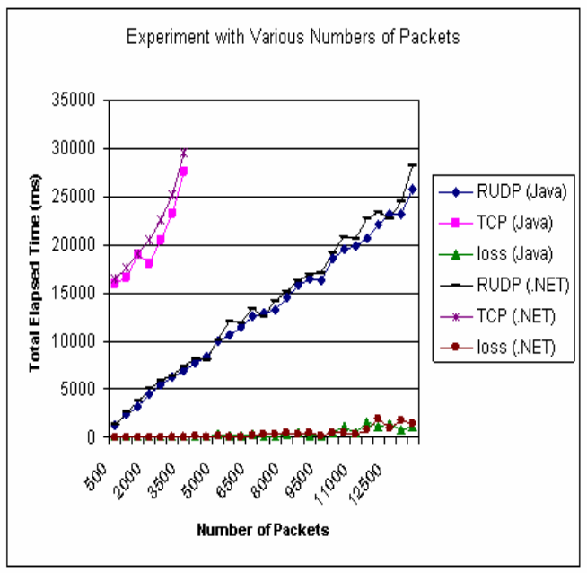
Fig 1 Performance Results with Various Numbers of Packets [1]

4.2 Performance Measurement on Maximum limitation of Packets
TCP has the limitation to establish TCP communication connections with the server. In the TCP communication, a server cannot accept more than 4000 packets, since a server cannot create the large number of sessions. In contrast, the RUDP does not have any limitation to accept packets: the more the clients want to send requests, the more the RUDP can process.

4.3 Performance Measurement on Various Sizes of Packets
The next experiment is to measure transmission time by changing packets sizes .The same number of packets generated was fixed to 2000 and the maximum waiting time is 1 second.
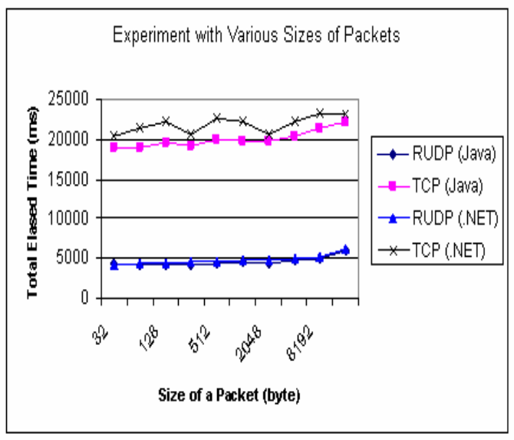
Fig. 2 Performance Results with Various Sizes of Packets[1]

4.4 Performance Measurement on Various RUDP Waiting Time
In this set of experiments, we want to observe the effect of the RUPD waiting time on the overall performance. We change the maximum waiting time of RUDP from one second up to ten seconds in this test set. The size of a packet is fixed to 1024 bytes and we test with two different sets: one with 2000 packets and the other with 5000 packets.

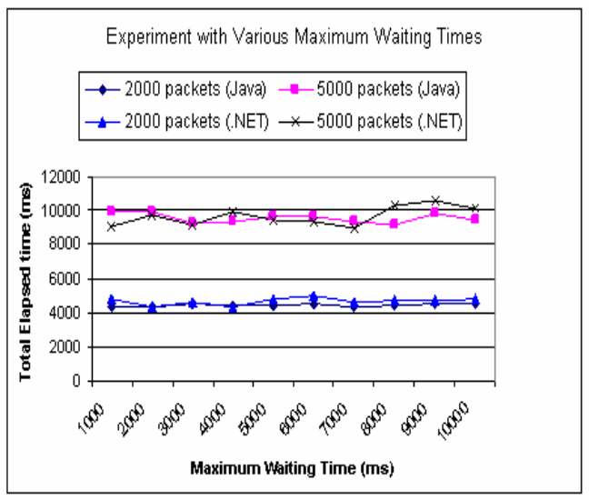
Fig 3 Performance Results with Various Waiting Times [1]

5. ROUTING IN 6LOWPAN
The routing protocol in 6LoWPAN is very sensitive because capabilities of nodes are limited and domain is fixed. Based on which layer the routing decision, Routing protocols in 6LoWPAN can be divided into two categories. the mesh-under and the route-over. Here we will give an analytical overview on Mesh-under routing.

5.1 Mesh-under Routing
In the mesh-under routing scheme, routing functions are placed at the data link layer. It is based on IEEE 802.15.4 frame structure and the 6LoWPAN header [2,8]. All fragments would be sent to the next hop by mesh routing protocol and reached to destination. Different fragments of one IP packet might reach the destination via different routing paths. If all fragments are received at the destination side successfully, the destination’s adaptation layer re-assembles all fragments into an desire IP packet. However, In forward process, for missing fragment, all fragments of this IP packet are retransmitted from the source.

6. ANALYSIS
In this section we ﬁnd out probabilistic for mesh-under schemes. Let assume that a received IP packet from the network layer is divided into f fragments by the adaptation layer of receiver end. Also, assume that h is the number of hops traveled by each fragment from source to destination.
6.1 Probability of Arrival of a Fragment
Let assume that In a single attempt p is the probability of successful arrival of a fragment in one hop distance. N is the number of tries to send a fragment to the next hop. So, after N times retries the probability of reaching a fragment, P, to one hop distance is given by Eq. 1.
P =N Xi = 1
P (1−p) i−1 …….(1)

6.2 Total Transmission of Packets
Let assume that the shortest routing path is characterized by the arrival of successful messages at intermediate nodes between the source and the destination. Starting at ith - intermediate node, make before reaching either source or destination 0, n, respectively. Here we would call this quantity m*i, i = 1,...,n − 1. The probability of jth, j ≥ 1, successful arrival of message at any intermediate node. The number of intermediate nodes/hops required for communication with ﬁnal destination will be calculated. Let B in Eq. 2, be the minimum number of intermediate nodes between source and destination.
B = Min{m : {m X j=1
Xj = −i_ j X j=1
Xj = n−i}}……. (2)
The total expected number of successful transmission in mesh-under Eq. 3.
E[B X j=1Xj] = pE[B]−q…… (3)
Here E[B], Eq. 4, denotes the expected number of fastest ferry and E[PB j=1 Xj] represents the expected number of successful transmission from the source to the destination. The successful routed packets,(in Eq. 3), depends upon the geometric probabilistic distribution at each hop.
B X j=1
Xj = n−i…,( with prob. α −i, with prob. 1−α)
(2p−1)E[B] = α−i…… (4)
E[B] =1 2p−1(n[1−(q/p)i] 1−(q/p)n −i)……. (5)
p is the probability of successful receiving and forwarding the packet/fragment while q = 1 - p is the failure probability at each hop.

6.3 Total Delay Between Source and Destination
Here, Twat is the waiting time in contention period. Tper is the propagation delay of a fragment and Tnode is the node processing time of a fragment. Now hop be the number of hops to be traveled and fr is the number of fragments. The total end-to-end transmission delay, Ttot, is:
Ttot = (Twat + Tper)hop + Tnode(hop−1) + (fr −1)(Twat + Tper) ……..(6)
In Eq. 6, (Twat+Tper)hop is the sum of the total waiting time in a contention period and the total propagation delay, Tnode(hop−1) is the total node processing time, and (fr − 1)(Twat + Tper) is the total waiting time for all fragments except the ﬁrst one for all nodes in the route.

7. OBSERVATIONS
From the probability analysis It is observed that no creation of IP packet is done at intermediate node and each fragment goes to the destination individually. So, the probability decreases after traveling each hop. There is no possibility of buﬀer overﬂow at intermediate nodes in mesh-under scheme. In case of the total delay mesh-under scheme does not have any overhead of reassembly and fragmentation at intermediate nodes but if the size of the IP packet is very large or the number of hops in the routing path is greater in number, then it has higher probability to lose fragments while routing. So, for small IP packet size or less number of hops like home automation or other Iot application mesh-under scheme may perform better. There is more probability to lose fragments in the path Mesh-under scheme when it is a noisy environment.

8.CONCLUSION
The next generation of computing technology will be outside the realm of the traditional desktop. In the Internet of Things (IoT) , many of the objects that surround us will be on the network in different forms as not in present time. Use of radio Frequency like Z-wave and wireless sensor network(WSN) technologies will rise to meet this new challenge, in which information system and communication technology are invisibly embedded in the environment around us. Smart device connectivity with existing network computation using network resources is an indispensable part of IoT. However, vision of the Internet of Things is to successfully emerge, the computing criterion will need to go beyond traditional computing scenarios that use portables or non-portable devices, and evolve into connecting everyday existing objects and embedding artificial intelligence into our environment. The new framework also have some major challenges been introduced ranging from appropriate interpretation and visualization of the huge amounts of data. through to the privacy, security and data management issues that must underpin such a platform in order for it to be genuinely viable. International initiatives is quite clearly accelerating progress towards IoT, providing an overarching view for the integration and functional elements that can deliver an operational IoT system over the world. World wide web connected us all. Using the internet Iot will also connect us all including living and non living things.

9. REFERENCES
[1] Aminul Haque Chowdhury, Muhammad Ikram, Hyon-Soo Cha, Hassen Redwan, S.M. Saif Shams, Ki-Hyung Kim, Seung-Wha Yoo. “Route-over vs Mesh-under Routing in 6LoWPAN”. June 21-24, 2009
[2] Doan Thanh Tran, Eunmi Choi.” A Reliable UDP for Ubiquitous Communication Environments”. January 17-19, 2007
[3] Jonathan Hui Pascal Thubert. “Compression Format for IPv6 Datagrams in 6LoWPAN Networks”. Appearing in 6LoWPAN WG Meeting, 74th IETF Meeting San Francisco, California. March 23,2009.
[4] Ju¨rgen Sch¨onw¨alder. “Internet of Things: 802.15.4, 6LoWPAN, RPL, COAP”. October 14, 2010
[5] Jayavardhana Gubbi,a Rajkumar Buyya,b* Slaven Marusic,aMarimuthu Palaniswamia. “Internet of Things (IoT): A Vision, Architectural Elements, and Future Directions”.
[6] Tsung Han Lee, Hung chi chu,Lin, Huang Chang, Hung Shiou Chiang and Yen Wen Lin. “Modeling and Performance Analysis of Route-Over and Mesh-Under Routing Schemes in 6LoWPAN under Error-Prone Channel Condition”. Journal of Applied Mathematics Volume 2013.
[7] N. Kushalnagaret al., ”IPv6 over Low-Power Wireless Personal Area Networks (6LoWPANs): Overview, Assumptions, Problem Statement, and Goals”, IETF RFC 4919, Augustt. 2007;
G. Montenegro et al., ”Transmission of IPv6 Packets over IEEE 802.15.4 Networks”, IETF RFC 4944, Sept. 2007.

